Specs for 2019 Forest River - Vibe
Floorplan: 22RB (Travel Trailer)
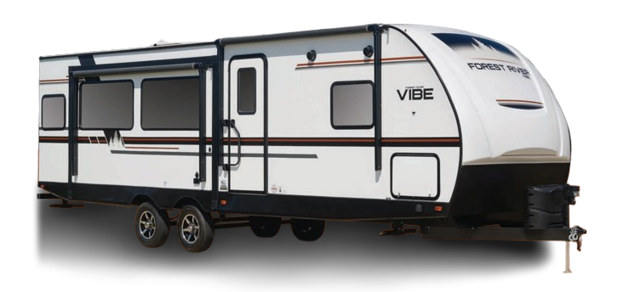

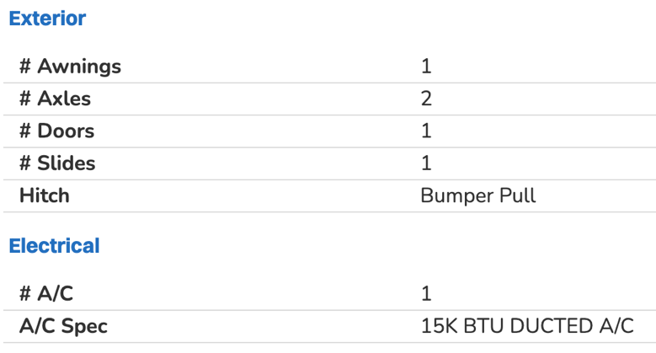
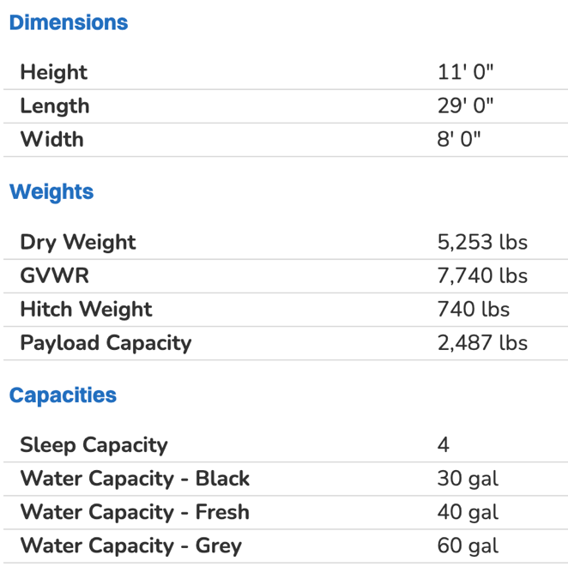
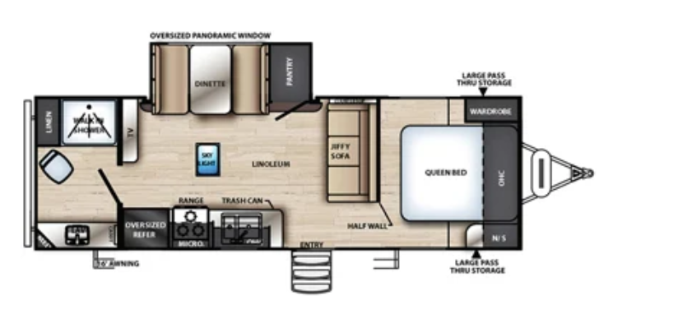
Features
EXTERIOR STANDARD FEATURES:
HYPER LYTE CONSTRUCTIONAMAZINGLY LIGHT!!!
VACUUM BONDED "ALUMA FRAME" SIDEWALLS AND 2" LAMINATED FLOOR
15K BTU DUCTED A/C
HIGH EFFICIENCY A/C COOLING SYSTEM (LARGER DUCT WORK)
ALUMINUM WHEELS
6 GAL. G/E DSI WATER HEATER
2-20# LP BOTTLES
CABLE & SATELLITE PREP
DIGITAL TV ANTENNA W/BOOSTER
EXTRA LARGE, ALUMINUM FRAMED, PASS THRU STORAGE
SPARE TIRE & CARRIER
OUTSIDE SHOWER
SPREAD AXLE SYSTEM
BACK-UP CAMERA PREP

INTERIOR STANDARD FEATURES:
12 VOLT EVERCHILL RESIDENTIAL REFER
EXTRA LARGE POTS & PANS DRAWER
DOMETIC PEDAL FLUSH TOILET
STD 26" CRYSTAL FIREPLACE (SELECT MODELS)
UPGRADED RESIDENTIAL STYLE CARPET
EXTRA LARGE SINGLE BOWL KITCHEN SINK
DECORATIVE GLASS INSERTS IN KITCHEN CABINETS
HARD DOORS TO BEDROOMS FOR PRIVACY NOT CURTAINS
SKYLIGHT OVER TUB/SHOWER AND KITCHEN AREA
LARGE TRASH CAN W/ DESIGNATED OUT OF THE WAY AREA

