Specs for 2022 K-Z - Sportsmen SE

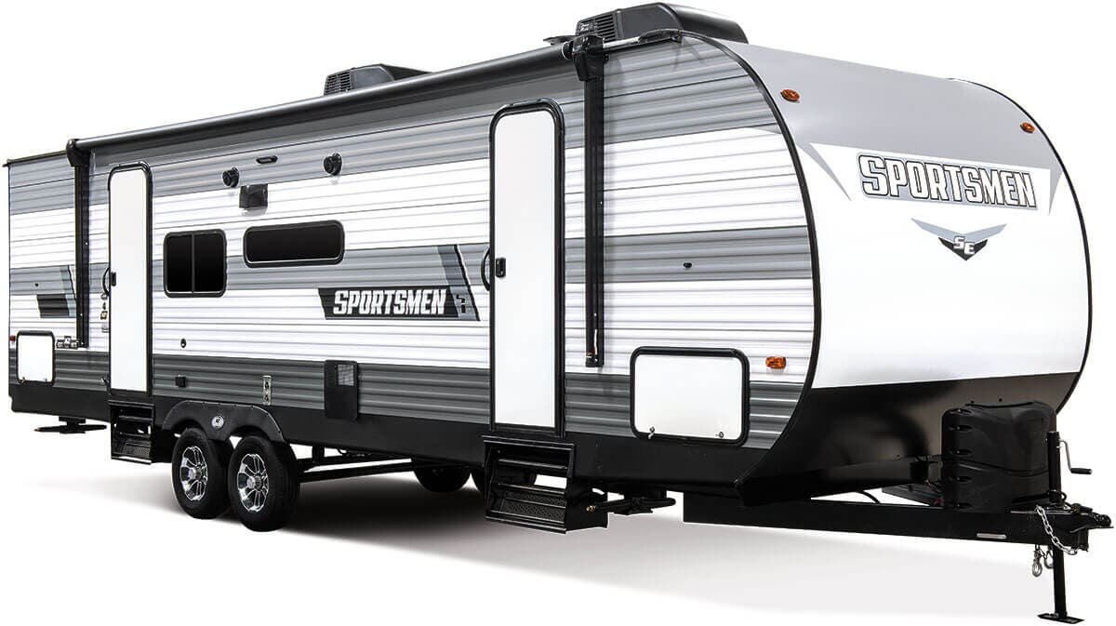
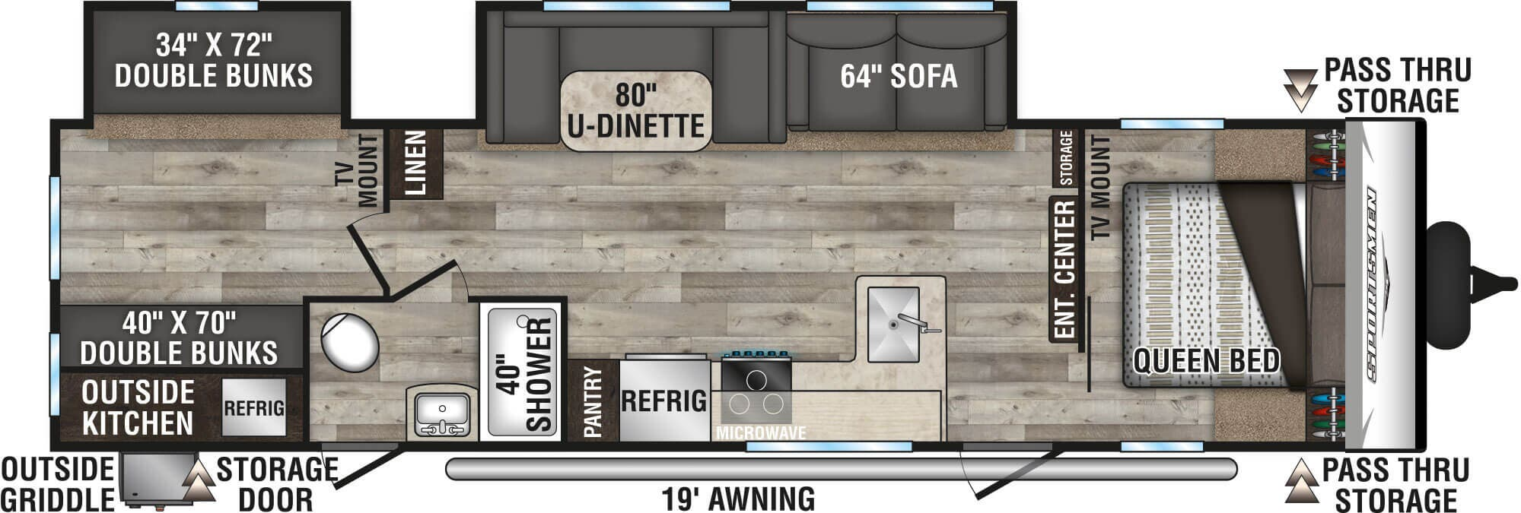
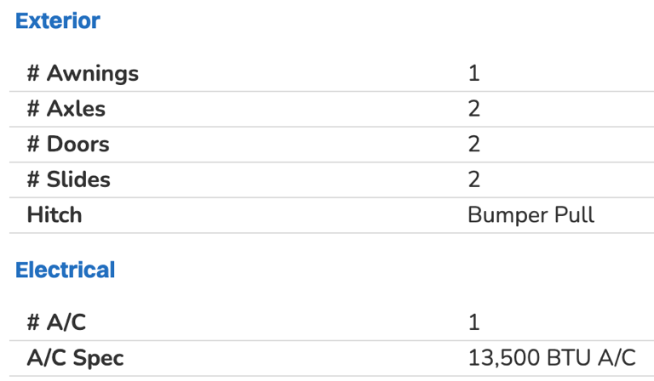
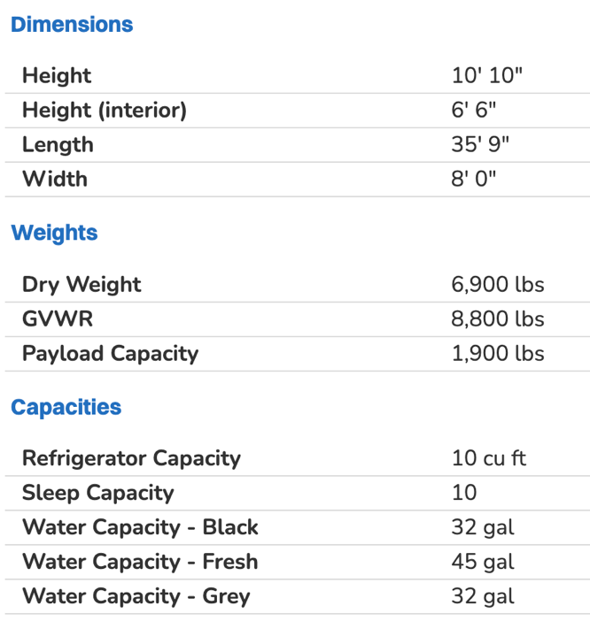
Features
STANDARDS
KZ Exclusive Tough Shield Exterior Metal
1-Piece, Seamless, Walk-on, Tufflex Roofing Material w/Lifetime Warranty
3/8" Fully Walk-On Roof Decking
Radius Truss Roof Rafters
Awning w/Drip Rail & Spouts
Radius Entry Door
Extra-Large Radius Baggage Doors
Tinted Windows
Diamond Plate Rock Guard
Rear Bumper w/Sewer Hose Storage
(2) 20# LP Bottles
30 AMP Service
Cable Hookup
Digital TV Antenna w/Booster
13,500 BTU A/C
Water Heater Bypass Kit
3-Burner Cooktop
Range Hood w/12V Light & Exhaust Fan
Microwave w/Turntable
Large Overhead Cabinets
Roller Ball Bearing Drawer Glides
LED Interior Lighting
Linoleum Throughout
Monitor Panel
Power Vent in Bath
Reversible Quilted Comforter
Shower Surround

50TH ANNIVERSARY PACKAGE (MANDATORY)
Climate Package (heated & enclosed underbelly)
Modern Farmhouse Interior
RV Airflow System
Solar Roof Prep

KZ ADVANTAGE PACKAGE (MANDATORY)
EXTERIOR
Climate Package
Exterior Shower
Aerodynamic Front Profile w/Smooth Metal Front
Outside Kitchens (select models)
Black Tank Flush
3-Toned Exterior Metal
Friction-Hinged Entry Door
Black Steel Wheels
Key-Alike Program for Entry & Baggage Doors
Exterior Speakers
Spare Tire & Carrier
Nitrogen-Filled Tires
(4) Stabilizer Jacks
LP Bottle Cover
Backup Camera Prep
Solar Roof Prep
Battery Disconnect
Leash Latch w/Bonus Beverage Opener

INTERIOR
RV Airflow System – A/C, Lithium Ready Converter
Jackknife Sofa w/Center Console & Built-in Bolster Arms
Sink Cover
Bedroom Shirt Closet Shelves w/Charging Stations
Drop-in Cooktop w/Glass Cover & Oven
(2) 12V USB Ports in Bedroom
Shower Pan
Seamless Countertops w/Deep Undermount Stainless Steel Kitchen Sink
Foot-Flush Toilet
(2) 6.5" Interior Speakers
Multi-Media Sound Bar Stereo w/Bluetooth
HDMI & USB Charge
Wider Pocket/Passage Interior Doors
Bathroom Shelf w/Towel Hooks

KZ CONVENIENCE PACKAGE (MANDATORY)
Power Awning
Magnetic Catches for Baggage Doors
Battery Disconnect Switch
Omnidirectional HDTV Antenna w/Wi-Fi Prep
Residential-Grade Linoleum
10 CU FT 12V Refrigerator w/Dual-Temperature Control (select models)
Black Residential Kitchen Faucet
Interior Control Switches on Overhead End Cabinet w/Convenience Center for Switches
Electric Outlet in Bunk Area
Microwave

