Specs for 2022 Dutchmen - Astoria
Floorplan: 2913FK (Travel Trailer)
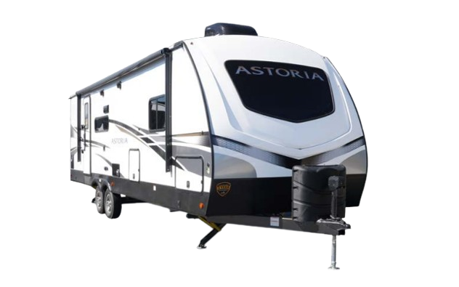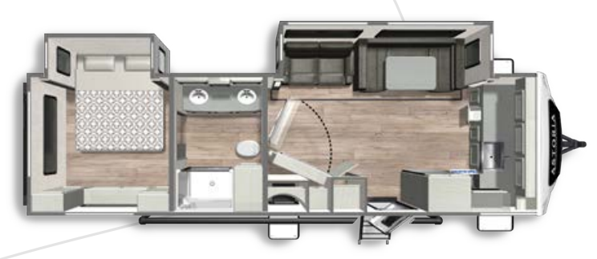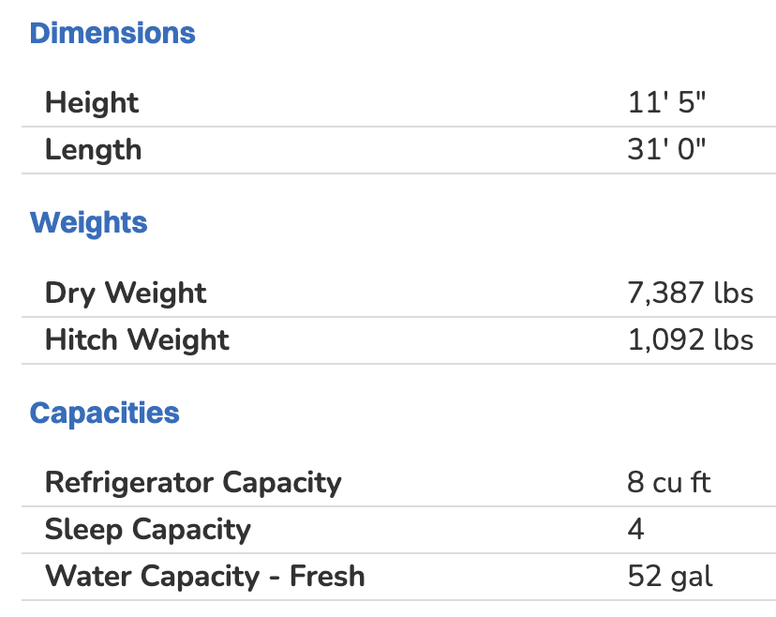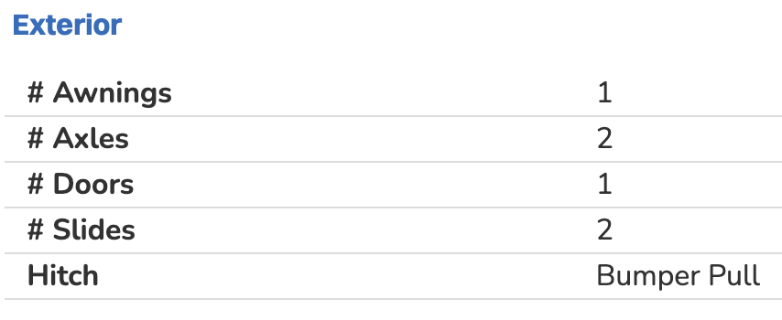
Features
STANDARD:
Power Tongue Jack
Power Stabilizer Jacks
Dual 20lb Propane Tanks
52 Gallons of Fresh Water
Motion Sensor LED Lighting
50 AMP
Prepped for WIFI 4G LTE

EXTERIOR:
Tinted Safety Glass Windows
Fiberglass Cap w/ Windshield
Outside Speakers w/ TV Bracket
Large Tinted Windows
Pass Thru Storage
2" Receiving/Towing Hitch (Select Models)
Vacuum Bonded Lamination
Premium Folding Entry Step
Exterior Spray Port
Heated and Enclosed Underbelly
Battery Disconnect
Under Mount Spare Tire
Aluminum Rims
Black Tank Flush

INTERIOR:
Arched Interior Ceiling
6 Gallon Gas/Electric DSI Water Heater
High Rise Pull-Out Faucet w/ Sprayer
8 cu. ft. Double Door Refrigerator
One-Piece Kitchen Countertops
Stainless Steel Appliances
Full Wall Acrylic Backsplash
Kitchen Countertop Extensions (Select Models)
Convertible U-Shaped Dinette
30" Glass Fireplace
40" LED TV
Theatre Seating/Tri-Fold Sleeper Sofa
King Size Bed w/ Gas Struts
Pop Up Power Station
Roller Shades
36" Pocket Doors (Where Applicable)
Washer/Dryer Prep*

